Project : Acmonan Elementary School – Annex
Location : Sitio Kafok, Acmonan, Tupi, South Cotabato

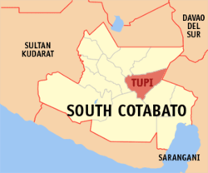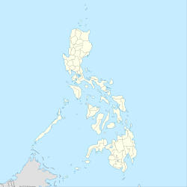
Equirectangular projection based on the parallel of
10°43' N N: 21.2° N S: 4.3° N W: 114.0° E E: 131.2° E
Coordinates: 6°20′N 124°57′E

NACSEA Relief made another journey how to help establish a public elementary school in the remote area and organize community networks with active participation of local government units, parents, teachers, and other stakeholders in giving access to quality education of cultural group.
Difficulty of transportation has always been the problem, in consideration of the home to school distances. As the team hike for 2hours and the on/off motorbike ride through solitary dirt roads, this is practically what the children had experienced without adequate safety and confronted by harsh weather conditions.
A school building has been the dream of the community and much efforts were exerted for its establishment by the continuous support given by the LGU officers and Sitio Kafok leader who donated 1000square meters of land for this project.
Sitio Kafok is home of 209 residents of which majority are New Apostolic members. It is situated on the Eastern part of Barangay Acmonan and is 12 kilometers away from the Municipal Hall of Tupi. It’s neighboring Barangays are Kablon and Linan. The place is composed of B’laan culture as its populace is dominantly 100% B’laan tribes.
The proposed site of the school project is 4.5kms from Acmonan Elementary School and 5kms from Ricardo O.Avila Elementary School.
At present, the children are holding classes on temporary classrooms made of light materials and much efforts have been done by the teachers to ensure an enabling and supportive environment for effective learning to happen.
The community were all very pleased and grateful that their dream for a school building will soon be realized. Total of 110 school children will benefit from this project.

Photo Report :
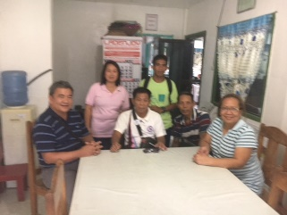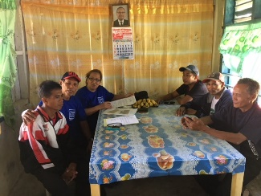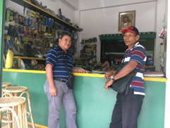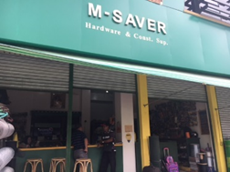
Meeting with LGU, Landowner& DepEd Canvassing of construction materials
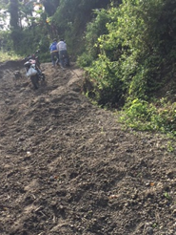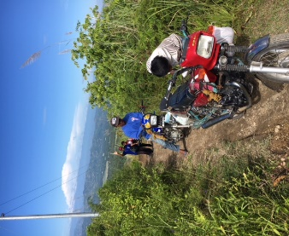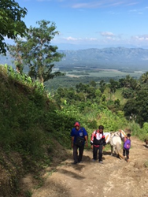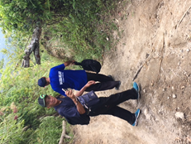
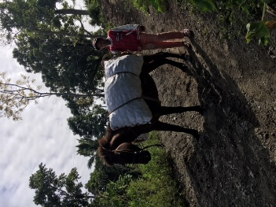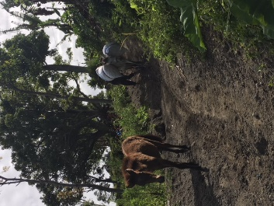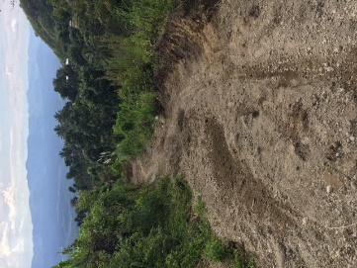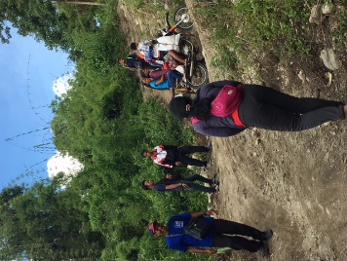
Navigating 5kms dirt road by foot and habal-habal ride going to Sitio Kafok
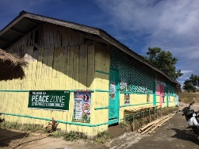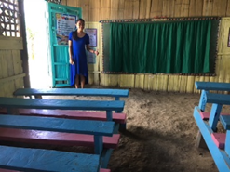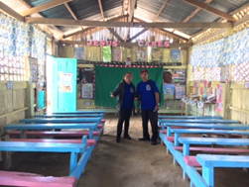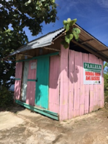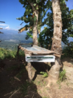
Temporary school facilities at Sitio Kafok
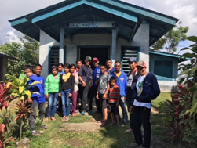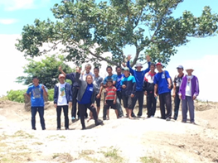
Proposed site of School Building Project

