NACSEA RELIEF RESPONS TO TYPHOON OMPONG & TYPHOON ROSITA VICTIMS 12.17-25.18
NACSEA RELIEF hand over a total of 810 kilograms of rice seeds comprising of RC18, SD, DX, 222, SL-8H, and Bigante varieties as seed support to 40-small scale farmers who have lost their source of income due to calamities. The seeds are for replanting to help them with their livelihood and quickly recover from the damage caused by Typhoon Ompong and Typhoon Rosita in Isabela and Cagayan.
Farmer-beneficiaries, expressed their deep gratitude because of the positive impact of this project to their livelihood. Poor conditions of farmers stem not only for availing rice seedlings but also from the acquisition of costly farm inputs – eventually dragging them to debts, especially with the occurrence of natural calamities. For those who owned no land, they tilled the soil as tenants and gained very small percentage after harvest.
They all had stories to tell and recapped that strong winds and intense rain from the typhoons, flooded their fields and farms as many crops were only weeks or even days away from harvest. For these farmers, there is no insurance to compensate for a destroyed crop and no rainy-day savings to bridge the gap.
Photo report:
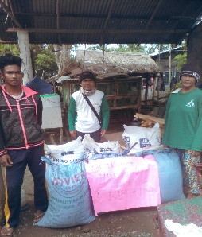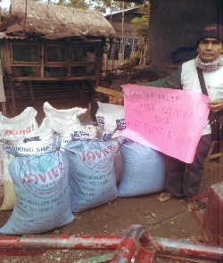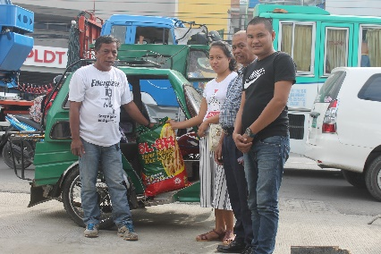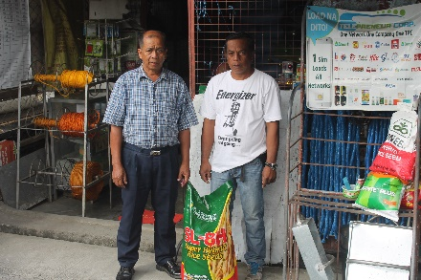
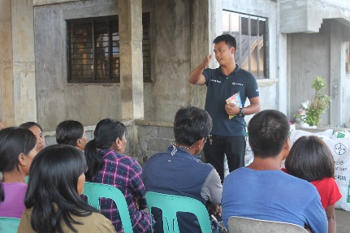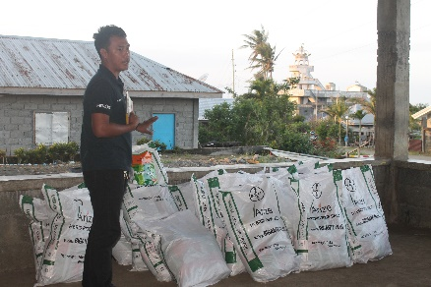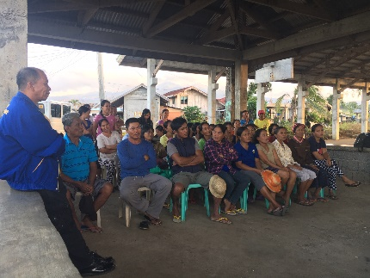
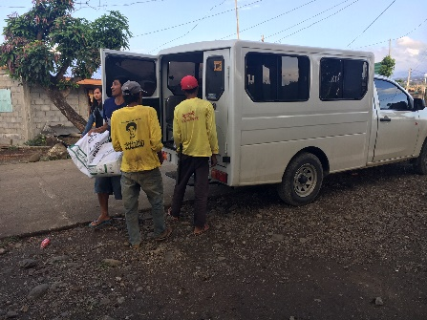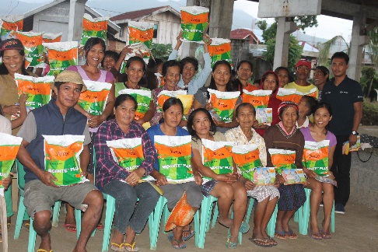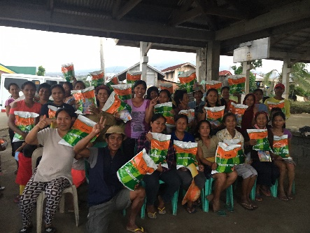
Apart from the rice seeding assistance, Isabela brethren receives materials for shelter to help them rebuild their homes due Typhoon Rosita (“Yutu”) that lashed their province last October 30, 2018 with strong winds and decimated number of houses As the weather improved, Evangelist Aguinaldo and Pr. Eduardo Idmilao recalled that everyone in their neighborhood began repairing their houses using salvaged iron sheets that the winds ripped off from roofs and carried away. Scattered sheets of wood they also collected and used to temporary build their shelters.
Everyone was very thankful that their dignity and safety will finally normalized as they received the housing materials assistance from NACSEA Relief.
Photo Report:
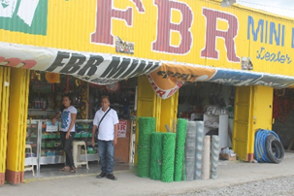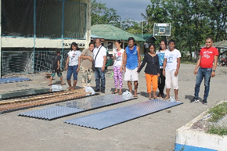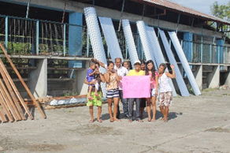
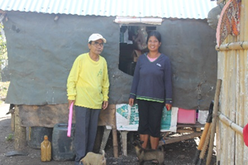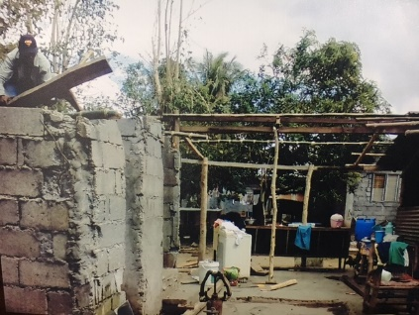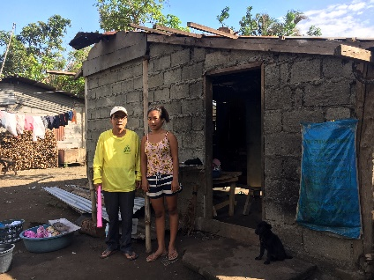
mfb17-21.2018
VISIT REPORT : MAGRAFIL CHURCH, GONZAGA, CAGAYAN:
After the field operations, NACSEA Relief went to help check progress of NAC Church building project in Magrafil , attended midweek worship service conducted by Priest Eduardo Idmilaoand offered simple snacks to the Sunday school children thereafter 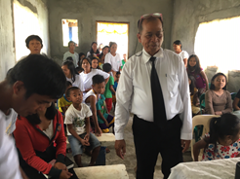 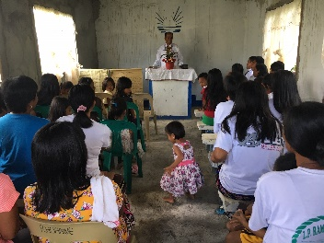 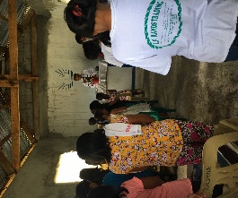 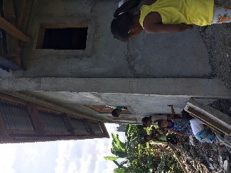 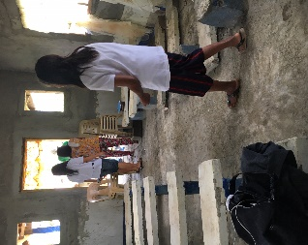 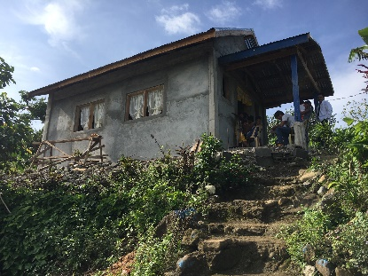 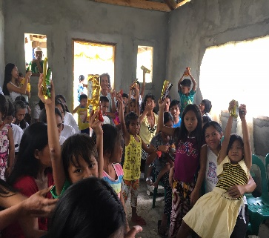 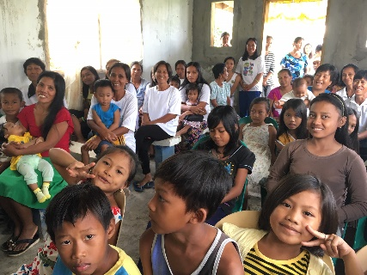

mfb21.12.18

