“humaNAKtiv” Germany sends NACSEA Relief to bring relief aid to residents of Oriental Mindoro & Semirara Island

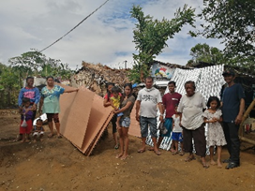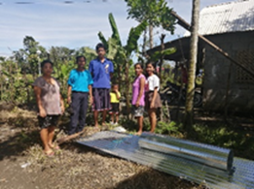
“PHANFONE” entered the Philippine Area of Responsibility (PAR) on 23 December 2019 and was named “Ursula” as the 21st Philippine tropical cyclone for 2019. On 24 December 2019, “Ursula” intensified into a typhoon as it moved toward Eastern Visayas; hence, also affecting Northeastern Mindanao, Bicol Region, Central Visayas, CALABARZON, MIMAROPA and Western Visayas. On 28 December 2019, “Ursula” weakened into a Tropical Storm (TS) and exited PAR. Source: DOST-PAGASA
NACSEA Relief has continued to bring relief assistance to the affected families of Typhoon Ursula in these provinces, supported by “humaNAKtiv” the humanitarian Aid Agency of NAC Southern Germany. The area of responsibility is 346.3 kms away from Manila and the team of Mabelle Bagtas and Rebekah Silvano has travelled for 13hours one way to reach the farthest community in Bulalacao, Oriental Mindoro.
Majority of the people thrive in the production of cassava, sweet potato, rice and corn for their subsistence. Banana and other vegetable crops such as eggplant, tomato and string beans are their source of income that are sold to the market and the earnings used to send their children to school and to buy school supplies. Still they face difficulties to support family needs and still rebuild their damaged shelters.
The beneficiaries were jubilant upon seeing the team bringing goodwill for their families devastated by typhoon Phanfone (Ursula). Corrugated sheets, marine plywood, lumber, umbrella nails, common nails were the items distributed to 14 families or 84 individuals located in 5-different locations e.g., Bulalacao, Bungabong, Pinamalayan, Barcenaga, and Semirara Island.
During distribution, NACSEARelief team encouraged the communities to come together and join forces to reconstruct what has been destroyed by typhoon Ursula such as their houses, plant crops and their physical environment. The families willingly accepted the challenge and were very grateful upon receiving the restoration supplies.
Photo Documentation:
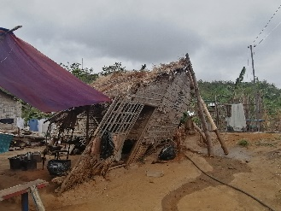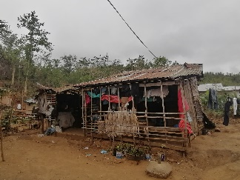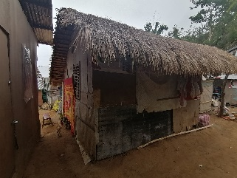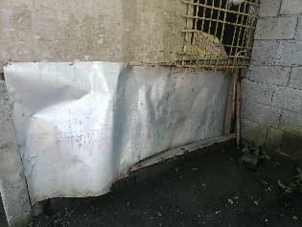
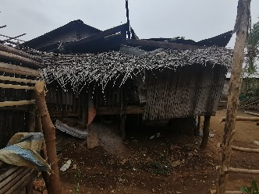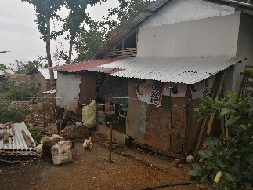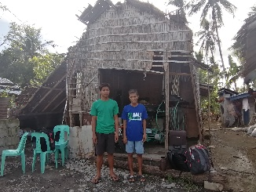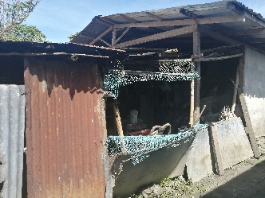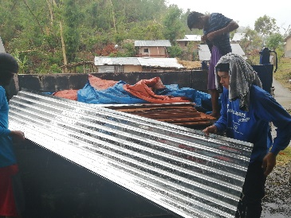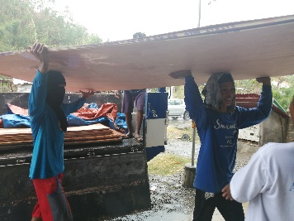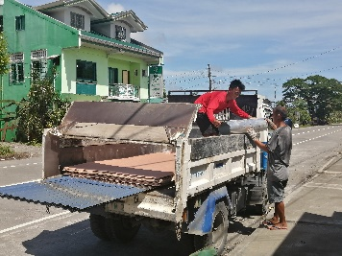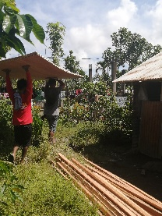
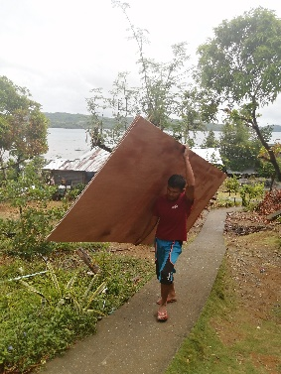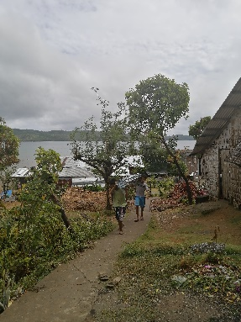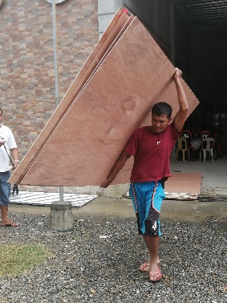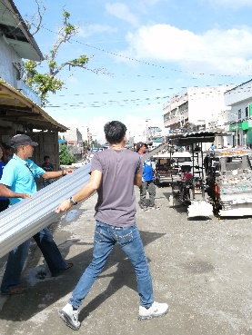
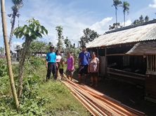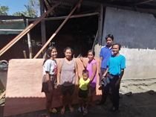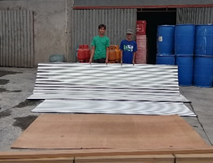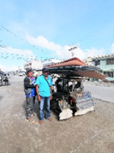
mfb02.10.2020

